Project overview

The goal of the project is to take the user on an experience that guides them through the defining genres of Bristol’s music scene. The intention is to provide insight into how music within the area has developed over the last 70 years and how that also influenced the city’s culture. Due to the immersive nature of VR, it will be an effective way of conveying the unique experience’s that each genre brought to the music scene, whilst also expressing context through real life individual accounts.

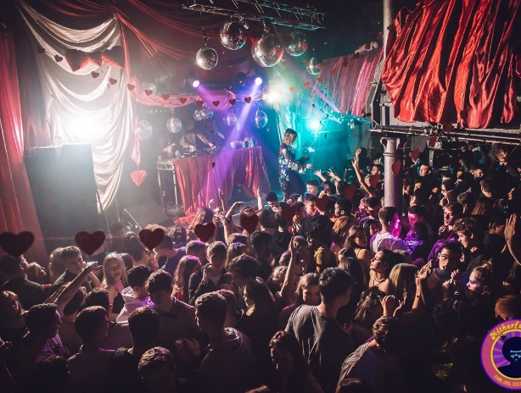There is a multitude of aims for what the experience should provide:

* Educate those who are unaware of the depth of history that Bristol’s music scene has to offer
* Demonstrate the varied change in clothing, fashion and culture that was inherent to each era
* Give real life context through first-hand perspectives and accounts of events
* Provide a nostalgic look back for users who might have experienced it themselves
* Take the user on an experience that is visually entertaining and obviously pleasing to listen to, that captures the essence of what being at these gigs/events was like

Narrative

The intention is to demonstrate the music and the culture that goes with it, in a way that makes the user feel educated and immersed at the same time. As a result, the flow of events and the structure in general will take on the form of a guided tour. The narrative will be primarily structured through the use of a voiced narrator and recounted interviews with different people who experienced the music scene first-hand.

The ‘menu’ of the experience will be a jukebox that allows the user to choose different music genres. The user will be placed in a variety of different settings that fit the specific genre being presented, each of which will be accompanied by a voice over introducing context that is pertinent to the era. They will then be presented with audio taken from interviews that will give the user insight that is relevant to the music being presented. This could include accounts of what the events were like to be at in person, what that music meant to them, or their experience with the culture in general. There will also be triggered events during each scene that go along with the interview, to keep the user engrossed in the experience.

The narration itself will be unique to each setting but will generally bring a calming atmosphere to the experience and will be used as a storytelling device to lead into the recital of the interviews. The tone will bring a colloquial nature to the experience, which will be beneficial because it will not only keep the user feeling relaxed but also allows for juxtaposition between genres when appropriate. Proper transitions will then keep the continuity between scenes, so as to not break the sense of immersion.

Setting

The experience will take place in a music venue which will be populated with dancing characters. The environment will change for each scene and and will embody the culture and style of the current genre.

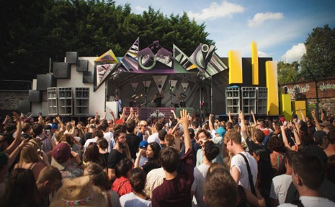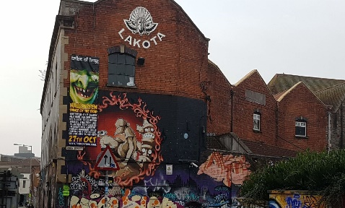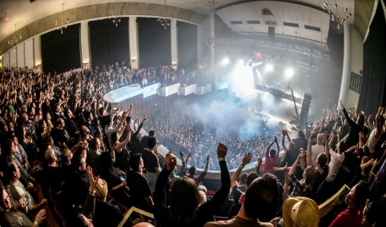The settings will mostly be based off of real music venues around Bristol that were popular for hosting the relevant music genres. This will be various locations; notable long-standing venues like Colston Hall and potentially popular clubs such as Lakota. This will greatly add to the appeal for the target users because they will be in recognisable places, that might link to personal experience they’ve had. This will also mean however that the virtual locations will have to be as accurate as possible to the real ones so that the intended immersion is not broken.

Musical genres

The most prominent genres over the last 70 years will be the base for the experience, these being rock/punk, reggae, hip-hop and rave music. The actual music used in the experience will ideally be the popular songs from each genre, the rights for most of which can be purchased at a low price or are public domain.

***Reggae:*** -Reggae music is quite popular throughout Bristol, starting in the city’s prominent Caribbean communities. Reggae influenced many of Bristol’s other popular music genres, specifically trip-hop and electronic genres such as drum and bass.

***Trip-Hop:***

-Hip-hop in Bristol broke away from the traditional music within the genre, spawning the music genre trip-hop in the early 1990’s. The genre combined hip-hop and electronica, also taking influence from genres such as funk, soul and R&B. The VR experience will look into the origins of trip-hop in Bristol, examining artists such as Massive Attack and Portishead.

***Rave Music:***

-Bristol’s rave culture was very prominent in the 1990’s up until today, still being very popular at present day. The experience will go into the origins of music genres such as Drum & Bass throughout Bristol.

Visual style

The experience will take on a low-poly stylistic art style, this would allow us to create an experience that is aesthetically pleasing without needing to go with a highly realistic look. A highly realistic art-style would be quite hard to achieve well and would be quite hardware intensive.

Characters will take the form of ethereal, ghostly like figures in the shape of people. They will be designed in such a way that they elicit the atmosphere of a dream or memory.

The transitions between scenes will be done in such a way that the user’s vision is obstructed through effects, without blinding them in an uncomfortable manner (this will also be true of effects in general). This way the environment can completely change without breaking the desired sense of immersion. These changeovers between each scene will be slightly catered to the relevant atmosphere, for instance transitioning between a punk gig and rave would have to be stylised to fit the flow of the experience.

Mechanics/interactivity/design

There will be minimal interaction; only the ability to press buttons to choose specific genres from the jukebox, move your hands around within the scene and potentially the interact with an occasional thing within the scene’s, like holding a drink. Your player model will be stationary, making each scene more of a linear guide.

A primary goal throughout will be to keep that sense of presence, which will be done by following one of the first rules of VR designas posed by virtual reality pioneerNonny de la Peña, “Begin by thinking of your body in the space, the focus of VR design is not the camera frame, but the embodied visitor.”1 (The experience will focus on replicating what being at these venues would really be like).

User research, interviews and relevant networking

The target audience for our project is based on research undertaken by Limina in their ‘Immersive Content Formats for Future Audiences’ report (Limina Immersive 2018) . One of the future formats they write about is called ‘Best Seat in the House’ which allows user to have a personal experience at an event such as a concert or carnival from the best possible view.

This format features:

* Placing the user amongst prominent groups such as musicians and actors
* A powerful sense of presence – obtained by the user’s close proximity to people around them
* Visually rich scenes and effective use of 360* degree space
* Lack of movement or ’roaming’. Described as a ‘sit back’ experience

According the report, this format will not necessarily draw in new audiences but is attractive to engaged audiences to extend their experiences or to be accessible for people that may not be able to have the experience of a concert normally. It may also appeal to people who want to relive memories, especially as the experience is heavily based on real events that happened in Bristol. This experience presents a high nostalgia value.

Much of the experience will be based on real life accounts of events, which will be obtained from interviewing members of the public around Bristol. These will either be: people who work or worked at the venues that are being modelled, people that are prevalent in the music scene at the moment, such as DJs and bands, or people that were part of iconic events in the past, such as St Pauls Carnival.  Due to this, the project also fits under Limina’s category of ‘Revisualising Testimony’; which are pieces that centre around a key moment in someone’s life. Part of this project is bringing memories back to life. According the user research, audiences enjoy this format more than the ‘Best Seat in the House’ – so combining them may make the project more appealing to wider audiences.  This format is particularly useful for visualising content from archives.

Part of the wider research is taken from the Centre for The History of Music in Britain, the Empire and the Commonwealth (CHOMBEC), at Bristol university, as well as the Bristol Archive Records. This well help understand in detail how underground music influenced Bristol, with primary historical sources. Some progress has already been made into visiting venues in Bristol for research and to photograph them for reference when 3D modelling them. We have been in touch with the Engagement and Heritage Officer for the Trinity Centre and are planning to visit in January.

*Interviews-*

The interviews will be conducted with a wide variety of people across Bristol. This is so that we get a lot of different perspectives, from people who will have a diversity of music tastes. These interviews will be recorded for use within the experience.

The questions will be related to each person’s individual experience and will lead them to talk about either their enjoyment of a certain genre, or discus any potential first-hand accounts they have of events. They will be encouraged to talk in a style similar to a monologue.

Example questions:

* Have you lived in Bristol for long?
* What is your favourite type of music?
* Have you ever been to any events in Bristol involving music?
* What genre would you say is the most prominent in Bristol’s music scene?
* Would you say that music has had an effect on the culture within the city?
* What is the most memorable venue you’ve visited?

Genre Limitations

In order to make the project suitable for an audience of any age group, some things cannot be included in the project.

Rave music and rock music has a lot of associations with the usage of recreational drugs and alcohol. It may not be appropriate to include references to these substances in the project – as our audience could include children. Although the experience may be less accurate, it is important to ensure that anyone can enjoy the project and that is accessible to all.

Storyboard draft

**Example setting Example of accompanying narration**

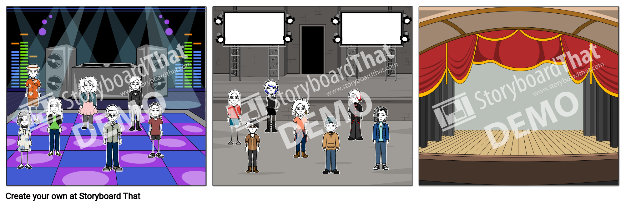

*“Rave music is at the heart of Bristol’s culture. The city is home to some of the most popular clubs in the UK, so what makes it so special?...”*



*“Punk and indie rock may not be the absolute most prominent genres in Bristol’s music scene, but they’ve definitely had their part to play…”*



*“You might recognise where you are…ever been to Colston Hall? Well if you haven’t, here’s your chance…"*

Scene Sketches

This are an idea of what each scene will look it, based on images found online.

# Trinity Centre:-

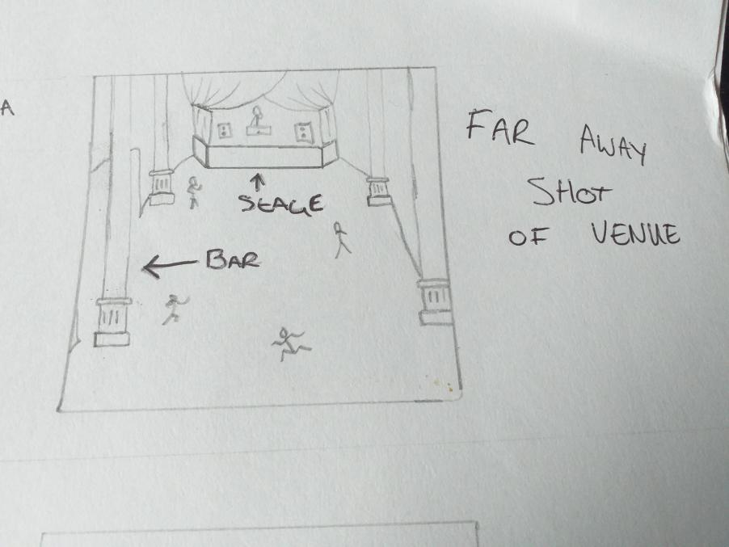

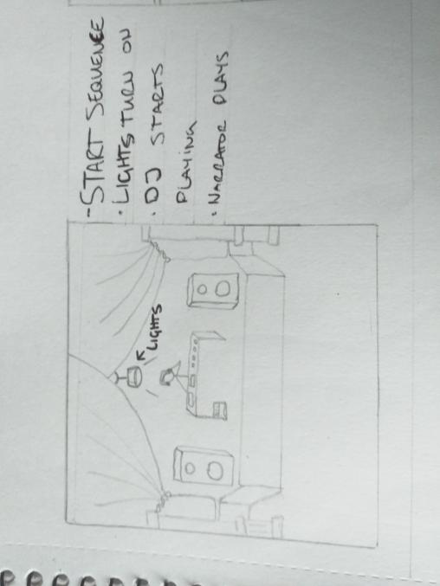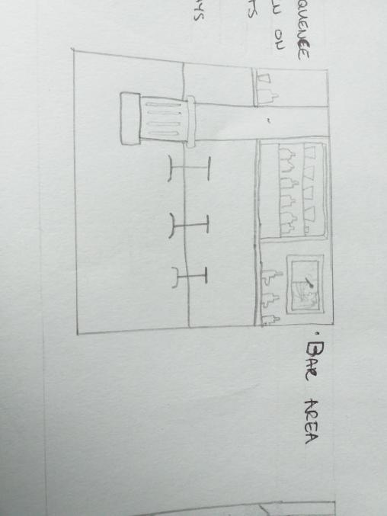

# The Fleece:-

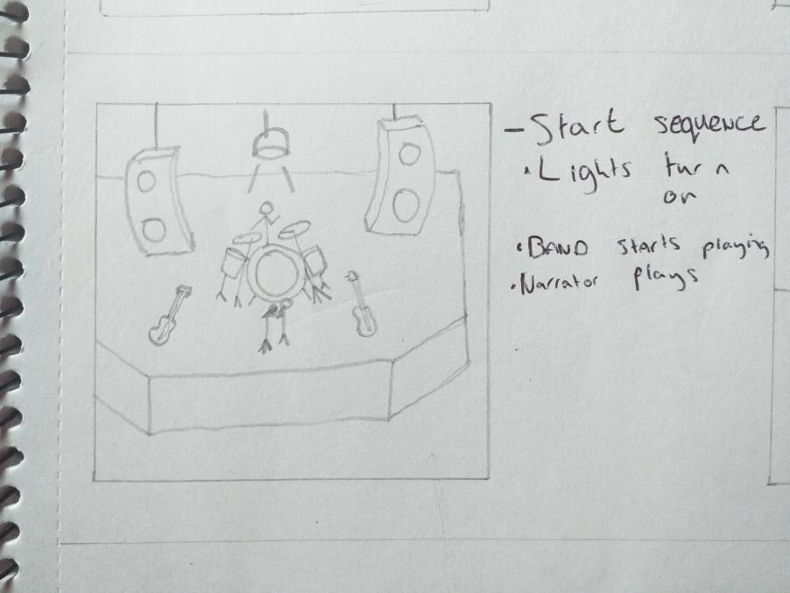

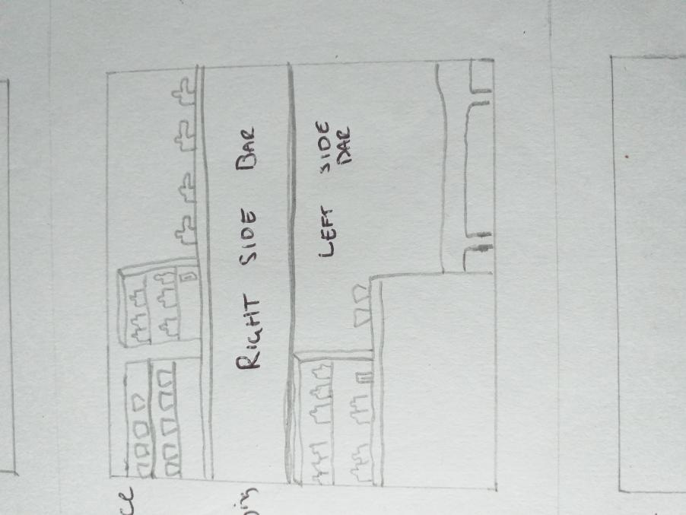

# Lakota:-

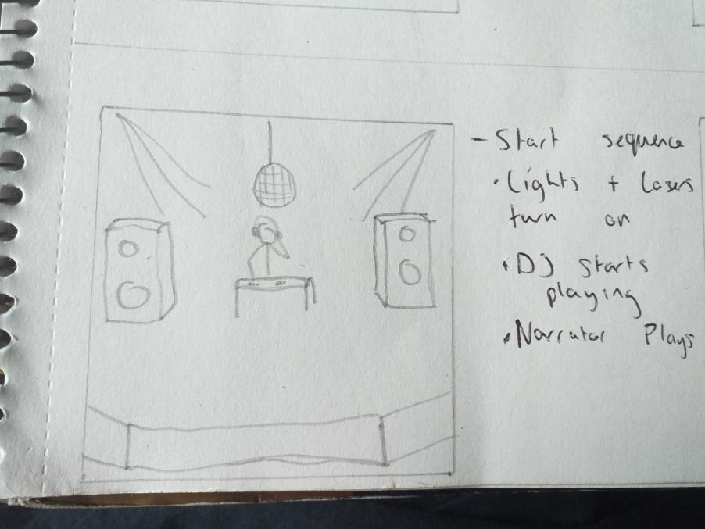

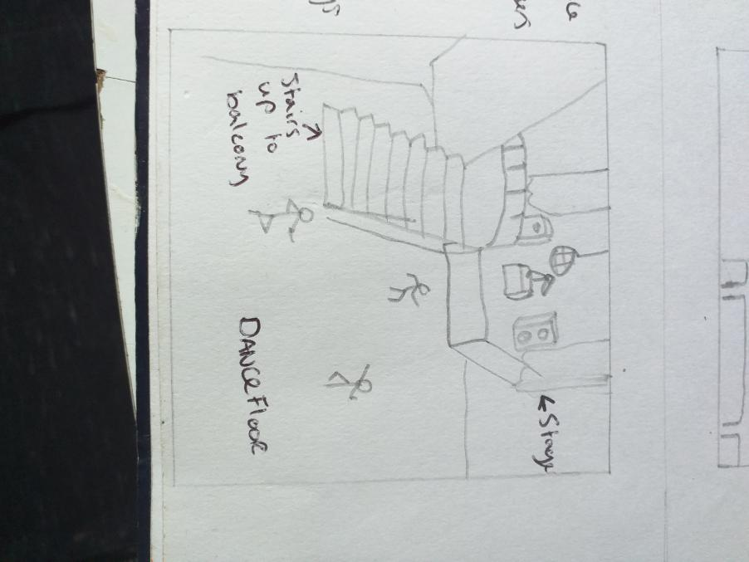

Project Plan

Moving forward, and dependent on feedback from the client – this is how we intend to proceed:-

* Reach out to local experts to gain insight on what to include in this project to ensure anything we include is authentic
* Based on this insight, select which venues to include
* Visit venues to take reference photos for modelling
* 3D model the venues in Maya
* Using the 3D models, create a rich and immersive environment
* Find suitable assets to use in the environment
* Write narrative introductions based on venue research and interviews

References

1. <https://www.ted.com/talks/nonny_de_la_pena_the_future_of_news_virtual_reality?language=en>
2. Immersive Content Formats for Future Audiences – Limina Immersive for Digital Catapult – 2018